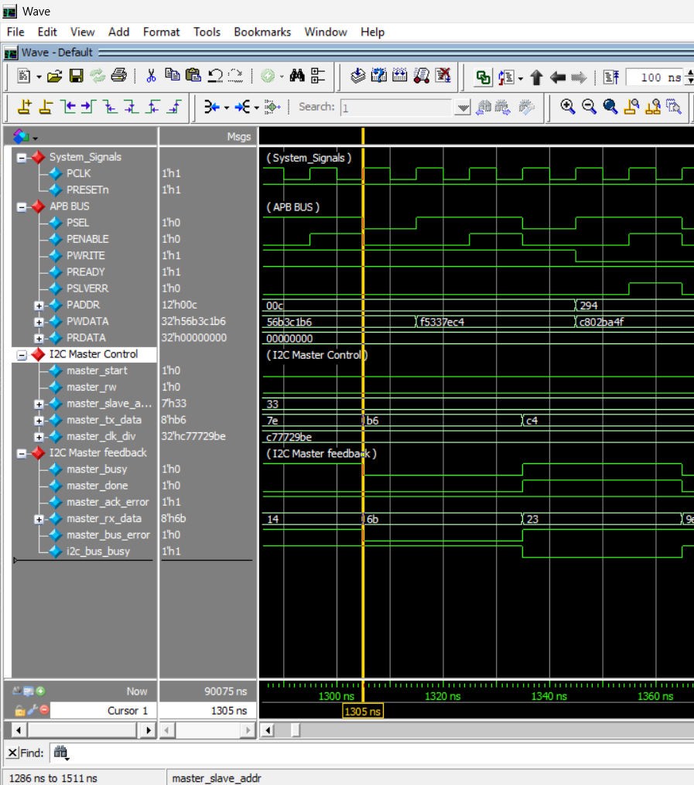
APB Write Transaction. SETUP phase (PSEL=1, PENABLE=0) followed by ACCESS phase (PENABLE=1) correctly writes data to the TX_DATA register.

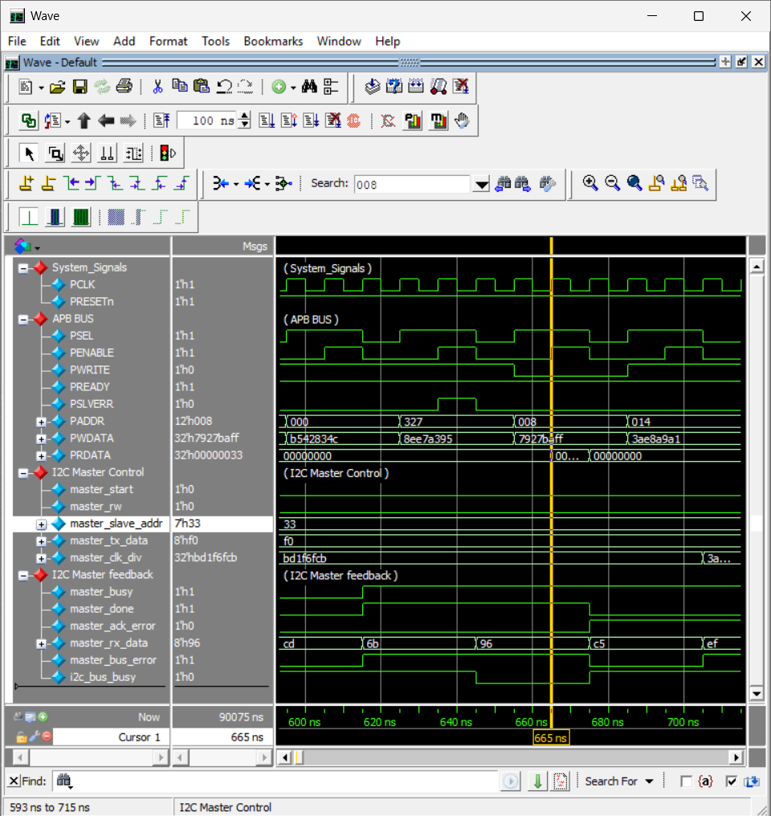
APB Read Transaction. Combinational read multiplexer outputs the correct internal register value to PRDATA during the ACCESS phase.
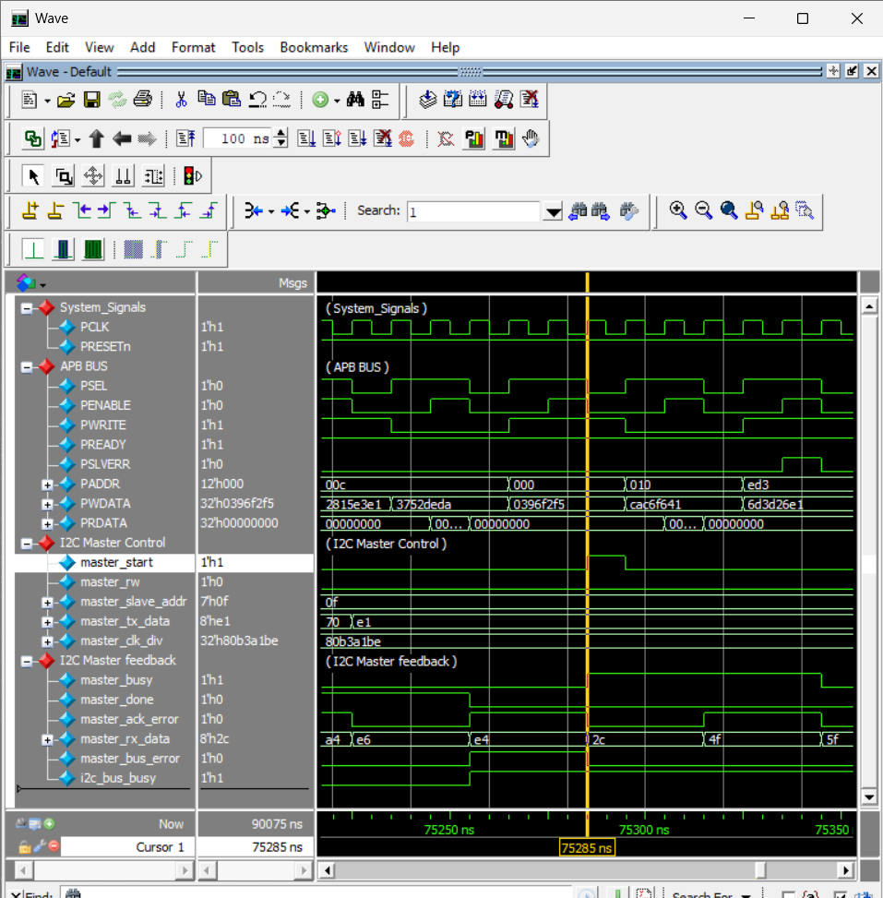
Verified: Command Pulse Generation. Writing 1 to CTRL[0] generates exactly one PCLK cycle of master_start.
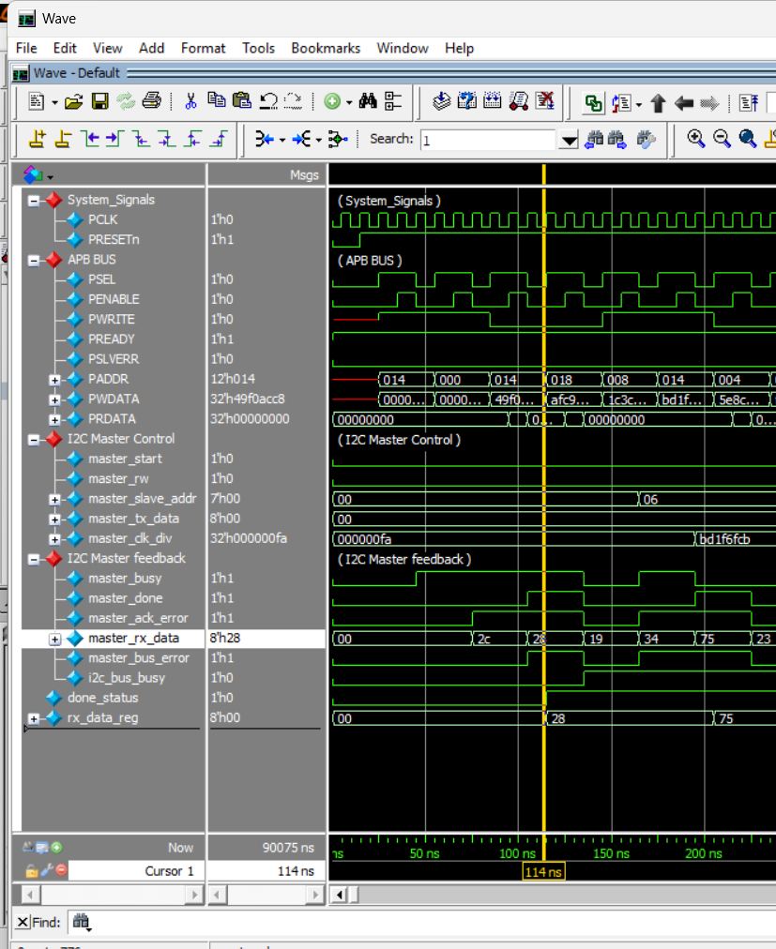
The register block successfully latches master_rx_data and master_done asynchronously from the I2C Master for the CPU to read.

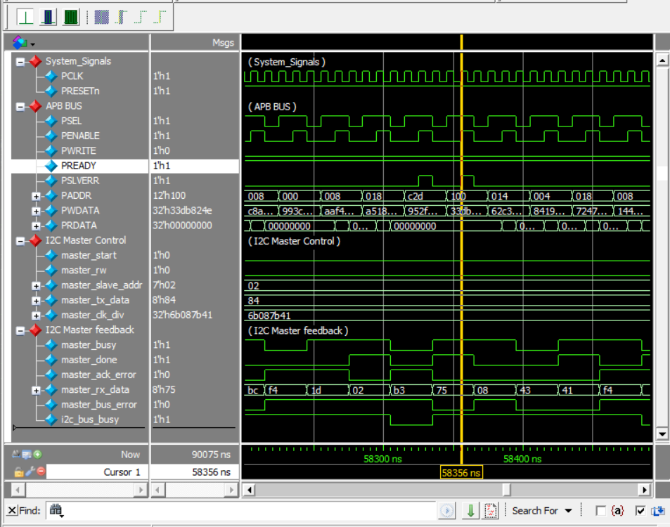
Accessing an unmapped APB address correctly asserts PSLVERR during the ACCESS phase, protecting the system from invalid memory operations.

